



**COLLEGE BUS MONITORING SYSTEM USING**

**INTERNET OF THINGS**

**MINI PROJECT - II**

***Submitted by***

**K MANOJKUMAR**

**ROLL NO: 727622MCA016**

*In partial fulfillment of the requirement for the*

*Award of the degree of*

**MASTER OF COMPUTER APPLICATIONS**

**Dr. MAHALINGAM COLLEGE OF ENGINEERING AND TECHNOLOGY POLLACHI – 642003**

**(Approved by AICTE, affiliated to Anna University and Accredited by NAAC with “A++” Grade)**

**JUNE 2023**

**Dr. MAHALINGAM COLLEGE OF ENGINEERING AND TECHNOLOGY**

**POLLACHI – 642003**

**DEPARTMENT OF COMPUTER APPLICATIONS (MCA)**

**MINI PROJECT – II REPORT**

**JUNE 2023**

This is Certify that the project entitled

**INTELLIGENT DATA COLLECTION USING POWER BI**

is the Bonafide record of project work done by

**K MANOJKUMAR**

**ROLL NO: 727622MCA016**

of Master of Computer Applications during the year 2022-2023

**-------------------------- ------------------------------**

Project guide Head the Department

**Dr. S. RAJA RAJESWARI ,M.C.A.,M.Phil.,Ph.D Dr. R.MUTHUSAMI,M.C.A.,M.Phil.,Ph.D**

**Assistant Professor/MCA Head & Assistant Professor (SG)**

Submitted for the Project Viva-Voice examination held on______________

**------------------------------ ---------------------------------**

**Internal Examiner External Examiner**

**DECLARATION**

I affirm that the project work titled **“COLLEGE BUS MONITORING SYSTEM** **USING INTERNET OF THING”** being submitted in partial fulfillment for the award of Master of Computer Applications is the original work carried out by me. It has not formed part of any other project work submitted for the award of any degree or diploma either in this or any other university.

_________________

(Signature of the Candidate)

**K MANOJKUMAR**

**REGNO: 727622MCA016**

I certify that the declaration made above by the candidate is true

__________________

(Signature of the Guide) **Dr. S. RAJA RAJESWARI,M.C.A.,M.Phil.,Ph.D**

**Assistant Professor/MCA**

**ACKNOWLEDGEMENT**

I express my gratitude to **Dr. C.RAMASWAMY, M.E., F.I.V., Ph.D., Secretary**, NIA Educational Institutions, Pollachi, for having provided me the facilities to do the project successfully.

I express my sincere thanks to **Dr. P.GOVINDASAMY, B.E., M.E, Tech., Ph.D.,** **Principal,** Dr. Mahalingam College Of Engineering And Technology, Pollachi, for having provided me the facilities to do the project successfully.

It is a great privilege and pleasure for me to express my gratitude to **Dr. A. SENTHIL KUMAR, B.E., M.E., Ph.D., Dean (Academic and Autonomous), Dr. S. RAMAKRISHNAN, B.E., M.E., Ph.D., Dean (Research & Innovation), Dr. CALVIN SOPHISTUS KING, M.Tech., Ph.D, Dean (Industry Relations and Talent Development),** Dr. Mahalingam College of Engineering and Technology, Pollachi, for persistent encouragement..

I own deep sense of gratitude to **Dr. R. MUTHUSAMI, MCA., M.Phil., Ph.D.,** Head of Department of Computer Applications for appreciating my goal. I express my sincere thanks for him for his constant encouragement.

I express my thanks to my guide **Dr. S. RAJA RAJESWARI, M.C.A., M.Phil., Ph.D.,** Assistant ProfessorDepartment of Computer Applications for her valuable guidance and support to meet the successful completion of my project.

I express my sincere thanks to all staff members of Department of Computer Applications for their encouragement and valuable guidance throughout this project.

Last but not the least, I would like to thank **my family** and **my friends** for putting up with me spending so much time providing encouragement and valuable suggestions, throughout the project tenure.

**ABSTRACT**

**ABSTRACT**

The college bus monitoring system using IoT is a project aimed at enhancing the safety and security of college students during their commute to and from college. This system incorporates various technologies such as GSM, GPS, and SMS to provide real-time monitoring and alerts to both the college authorities and the parents of the students.

The system uses GPS to track the location of the bus in real-time and sends SMS alerts to the students and their parents when the bus is 10 minutes away from the bus stop. This helps students and parents to plan their time accordingly and avoid any delays or inconveniences.

The system also includes a fingerprint scanner, which is used to send an SMS to the parents once the student boards the bus. This provides parents with peace of mind and ensures that their child has safely boarded the bus.

Overall, the college bus monitoring system using IoT is a comprehensive solution that ensures the safety and security of college students during their commute to and from college.

##### **TABLE OF CONTENTS**

|  |  |  |
| --- | --- | --- |
| **CHAPTER NO** | **TITLE** | **PAGE NO** |
|  | **ABSTRACT** | **v** |
|  | **LIST OF FIGURES** | **viii** |
|  | **LIST OF ABBREVIATIONS** | **ix** |
| **1** | **INTRODUCTION** | **1** |
|  | 1.1 Objective | 1 |
| **2** | **SYSTEM ANALYSIS** | **2** |
|  | 2.1 Existing System | 2 |
|  | * 1. Proposed System   2. Requirement Gathering      1. Functional Requirement      2. Non-Functional Requirement | 3 |
| **3** | **SYSTEM SPECIFICATION** | **6** |
|  | 3.1 Hardware Specification | 6 |
|  | 3.2 Software Specification | 6 |
| **4** | **SOFTWARE DESCRIPTION**   * 1. Programming Language   2. Development Tools and Technologies | 7 |
|  | 7 |
|  | 8 |
| 5 | **PROJECT DESCRIPTION** | **10** |
|  | * 1. Problem Statement   2. Overview Of Project   3. Module Description | 10  10  10 |
|  | 5.4 System Design | 11 |
|  | 5.4.1 System Flow Diagram | 11 |
|  | 5.4.2 Data Flow Diagram | 12 |
|  | 5.4.3 Entity Relationship Diagram | 14 |
|  | 5.4.4 Use Case Diagram | 15 |
|  | 5.4.5 Database Design | 16 |
|  | 5.5 Input Design | 19 |

**CHAPTER 1**

**INTRODUCTION**

**1.1 Objectives**

The college bus monitoring system using IoT is a project that aims to improve the safety and security of college students while they are commuting to and from the college campus. The system uses various technologies such as IoT, GSM, GPS, and SMS to provide real-time monitoring of the college bus, which allows for better tracking and management of the bus.

One of the main features of this system is the SMS alert system, which sends notifications to parents before the bus reaches their designated bus stop. This helps to ensure that students are picked up on time and provides parents with peace of mind knowing that their child is safely on their way to or from college.

Another important aspect of the system is the use of fingerprint authentication to send SMS messages. This feature ensures that only authorized individuals can send messages, providing an added layer of security and reducing the risk of false alarms or unauthorized use of the system.

Overall, the college bus monitoring system using IoT is an innovative and effective solution for improving the safety and security of college students during their daily commute.

**1.2 Overview of Project**

A college bus monitoring system using IoT involves the use of various technologies such as GSM, GPS, and fingerprint recognition to provide real-time tracking and monitoring of college buses. The system can send SMS alerts to parents before 10 minutes of reaching the bus stop to ensure that they are aware of the bus's location and arrival time.

The system can be designed to use GPS to track the bus's location and provide real-time information on its route, speed, and other important parameters. The system can also use GSM to send SMS alerts to parents and other stakeholders, informing them about the bus's location and estimated time of arrival.

Fingerprint recognition technology can be used to send SMS alerts to parents, confirming that their child has boarded the bus safely. This ensures that parents are kept informed and reassured about their child's safety.

Overall, a college bus monitoring system using IoT can improve the safety and security of students by providing real-time tracking and monitoring of college buses. It can also help reduce the risk of delays and improve the overall efficiency of the transportation system.

**1.3 Objective of Project**

The objective of the college bus monitoring system using IoT is to provide a secure and efficient solution for tracking college buses and ensuring the safety of students during their commute. The system will be developed using a combination of GSM, GPS, and SMS technology, and will feature a fingerprint authentication system to send SMS alerts to parents.

Specifically, the system will aim to

1. Improve student safety: The system will provide real-time location tracking of the college bus, enabling parents and college authorities to monitor the bus's movement and ensure that students are safe at all times.

2. Increase efficiency: The system will help optimize bus routes, reducing travel time and fuel consumption, and improving the overall efficiency of the transportation system.

3. Provide timely alerts: The system will send SMS alerts to parents before the bus reaches their child's stop, giving them ample time to prepare for pickup and ensuring that no student is left behind.

4. Ensure secure access: The fingerprint authentication system will prevent unauthorized access to the system and ensure that only authorized personnel can send SMS alerts and access the system data.

Overall, the objective of this project is to develop a robust and reliable college bus monitoring system that leverages the latest IoT technology to improve student safety and transportation efficiency.

**1.4 Problem Statement**

* Blind people can’t easily recognize obstacles or stairs while using a normal blind stick
* No safety features on the normal blind stick.
* Can’t locate the location of the normal blind stick user when they are having an emergency problem or are lost in a public area.

**Significance of the Project**

Improved safety and security for students riding the bus: The use of GPS and GSM technology could help the school keep track of the bus's location in real-time, allowing for better monitoring of the bus and its passengers.

Increased convenience and communication: The SMS alert system could provide students and parents with real-time updates on the bus's location and estimated time of arrival, making it easier for them to plan their schedules accordingly.

Enhanced accuracy and efficiency: The use of fingerprint identification technology could help streamline the process of verifying student identity, reducing the potential for errors or delays.

**CHAPTER 2**

**LITERATURE REVIEW**

**2.1 Smart Walking Stick Using Ultrasonic Sensors and Arduino**

This project was developed by (M.H. Mahmud, R. Saha and S. Islam). The author proposes a function of a micro-controller that have code protected so its security bridge cannot be override except the vendor or owner. It produces different Pulse Width Modulation (PWM) based on the sensors output to operate pager motor. The author focused on the easy way to use the stick and it’s maintain, cheap and it is very comfortable to use for blind people. The author approach with subsystems fundamentally sensor based with integral scheme is designed with a circuitry fundament on a PIC micro-controller. The power consumption is low and can be operated easily. The stick is very economic over the conventional one. The Smart Stick acts as a basic platform for the coming generation of more aiding devices to help the visually impaired to navigate safely both indoor and outdoor. It is effective and affordable. It leads to good results in detecting the obstacles on the path of the user in a range of three meters. This system offers a low-cost, reliable, portable, low power consumption and robust solution for navigation with obvious short response time.

**2.2 A computerized Travel aid for the Active Guidance for the Blind Pedestrians**

The author convinced a stick which allowed a sighted assistant to steer the Guide Cane remotely. A sightless subject would then walk with the Guide Cane, “steered” by the assistant radio-control joystick. The author focused on how to steer the stick so the sensor head is mounted on a steerable with two unpowered wheeled steering axle. The author approach with the ultrasonic sensors that detect any obstacle in a 120o wide sector ahead of the user. Using UM’s previously developed, patented obstacle avoidance technique called “Vector Field Histogram” (VFH) in combination with UM’s patented “Error Eliminating Rapid Ultrasonic Firing” (EERUF) method for firing the sonars, allows for travel at fast walking speeds.

**2.3 A Multidimensional Walking Aid for Visually Impaired Using Ultrasonic Sensors with Voice Guidance**

The author propose that voice can being consequently activate by micro-controller when detect any obstacle to warn the sightless subject. The author approach using with a 40 KHz signal sent out by the ultrasonic transmitter.

This will be reflected back to the ultrasonic receiver in case there is an obstacle along the pathway of the stick, and this activates one of the input pin of the micro-controller. Once this happened, the micro-controller will consequently activate the voice recording microchip which then gives the relevant output via the speaker.

The author focused on how to make the voice guidance as a platform to ease and help the sightless subject.

**2.4 Implementation of Micro-controller Based Mobility Aid for Visually Impaired People**

The author convinced the proposed that LDR gives a very high resistance value ranging up to 2MΩ and in the day time or when there is sun light it give a low resistance ranging to 100Ω and sometimes below.

From the voltage divider network at day time the voltage from the LDR is lower there by making pin 2 lower than pin 3 of the comparator giving an output voltage of 0V and at night the VLDR is high making pin 2 greater and the comparator output 5V.

The author focused on how LDR can function on white cane with the proper circuit. The system consists of an ultrasonic sensor for obstacle detection, and a light dependent resistor for dark detection. Each sensor is differentiated from one another through pattern of sounds.

**CHAPTER 3**

**SYSTEM ANALYSIS**

**3.1 Existing System**

In the Existing System,

GPS Tracking: The bus would be equipped with a GPS tracking device that constantly sends location data to a central server. This would allow students and parents to track the bus in real-time using a mobile app or web interface.

GSM Module: The system would use a GSM module to send and receive text messages. This would enable the system to send SMS alerts to students when their bus is approaching their stop.

SMS Alerts: When the bus is 10 minutes away from a student's stop, the system would send an SMS alert to the student's phone, letting them know that their bus is approaching and that they should be ready to board.

Fingerprint Scanning: In order to ensure that only authorized students are able to board the bus, the system would use fingerprint scanning technology to identify students. This would eliminate the need for physical bus passes or ID cards, making the process more efficient.

SMS to Parents: After the student has been identified using fingerprint scanning technology, the system would automatically send an SMS message to their parents, letting them know that their child has boarded the bus and is on their way to school.

**3.2 Proposed System**

In the Proposed System, We develop a College Bus Monitoring System using IoT that incorporates GSM, GPS, SMS Alert, and Fingerprint technology. The system aims to provide real-time information on the location of the bus, its route, and estimated time of arrival at each stop. It also includes a student identification system using fingerprint technology to ensure the safety and security of students on board.

The system consists of a GPS module that tracks the location of the bus and sends the data to a micro-controller. The micro-controller then processes the data and sends it to the GSM module, which sends SMS alerts to students and parents about the estimated arrival time at their stop.

The fingerprint identification system is used to identify the student boarding the bus. Each student's fingerprint data will be stored in the micro-controller, and when a student boards the bus, they will be required to scan their fingerprint. The system will verify the identity of the student and send an SMS alert to their parent that their child has boarded the bus.

The proposed College Bus Monitoring System is intended to provide an efficient and effective way of monitoring the college bus fleet and ensuring the safety and security of students. It will also provide real-time information to students and parents about the bus's location and estimated time of arrival, which will help them plan their schedules accordingly.

**CHAPTER 4**

**SYSTEM REQUIREMENT**

**4.1 Hardware Requirement**

Micro-controller board : Arduino Uno(ATmega328P)

USB cable : Uploading the code

Wires Used : Jumper wires

Sounding Device : Buzzer

LED (light-emitting diodes)

Resistor 1v and Transistor

Sensors Used : Ultrasonic Sensor(HCSR04) and IR Sensor

GPS NEO-6M0-001 Module

GSM/GPRS Module : SIM800A

Power Source : 12v 2 amp Adaptor

**4.2 Software Requirement**

**IDE**:  Arduino 1.8.19

**Programming Languages:** It is based on C++

**4.3 Hardware Specification**

**Arduino Uno(R3)**

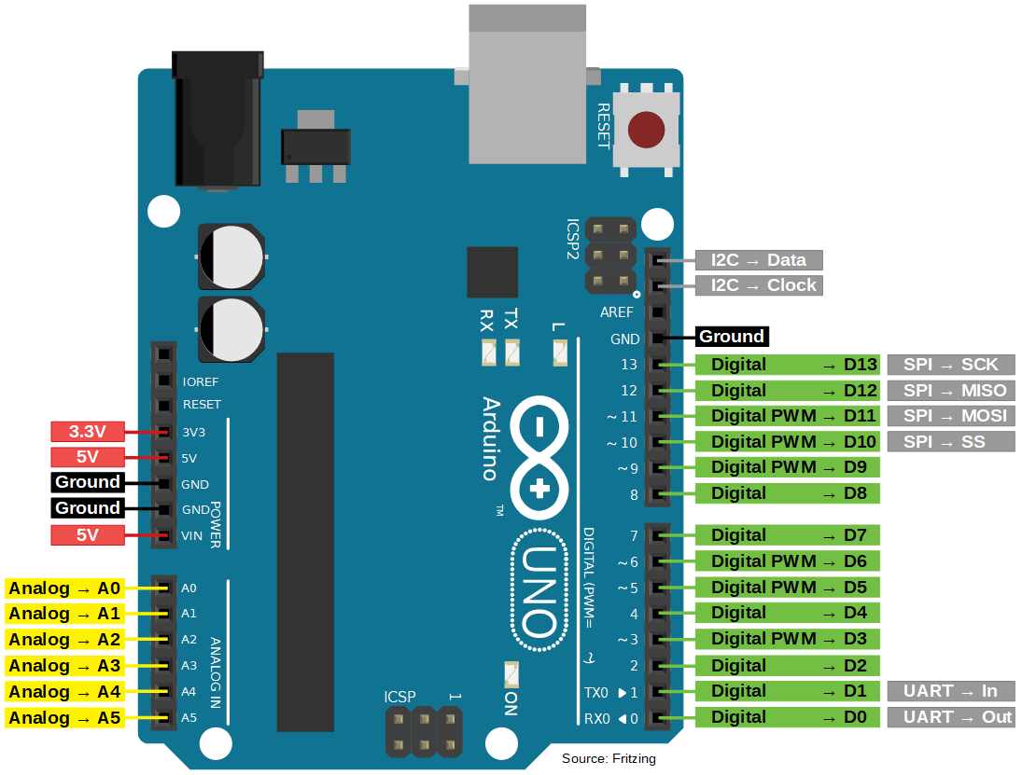

Arduino UNO is a micro-controller board based on the ATmega328P. It has 14 digital input/output pins (of which 6 can be used as PWM outputs), 6 analog inputs, a 16 MHz ceramic resonator, a USB connection, a power jack, an ICSP header, and a reset button. It contains everything needed to support the micro-controller; simply connect it to a computer with a USB cable or power it with an AC-to-DC adapter or battery to get started.

**USB Cable**

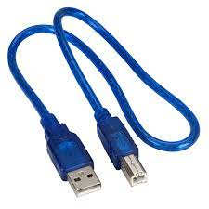

**Arduino USB Type-C® Cable 2-in1**

Through a USB-C® to USB-C with a USB-An adapter connection, this data USB cable can easily connect your Arduino boards with your chosen programming device.

**Blank PCB Board**

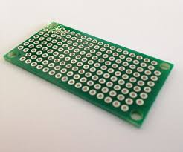

Usage of a blank PCB board in an Arduino Uno project is to create a custom breakout board. A breakout board is a board that takes signals from a micro-controller and breaks them out into separate headers or connectors for easier prototyping or testing. A blank PCB board can be used to design and create a custom breakout board for the Arduino Uno to make it easier to connect to external devices or sensors.

**Multi-Color Wires**

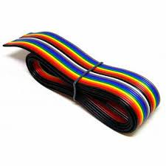

In Arduino Uno, multi-colored wires are commonly used to connect various components to the board, such as sensors, LEDs, motors, and other electronic components. The colors of the wires indicate their purpose or function, and this helps in organizing and managing the wiring connections**.**

**Specifications of Jumper Wires**

* Length: 240mm x 4, 200mm x 4, 150mm x 8 and 110mm x 49
* 7 different colors
* Colors: Red, green, blue, black, orange, white, and yellow
* Material: Plastic
* Connect to PCB and Arduino

**Power Supply**

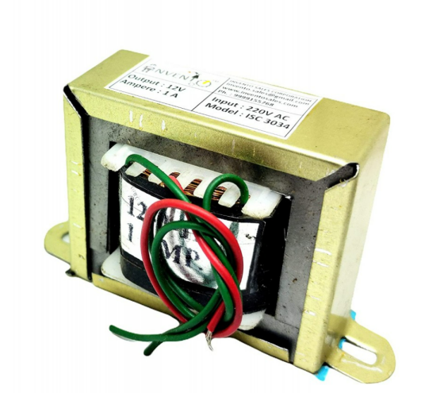

Transformers power supplies can be used to power an Arduino Uno board. Transformers are used to step down the voltage of the AC power source to a suitable level for the Arduino board.

The Arduino Uno board requires a DC voltage between 7V and 12V to operate. Therefore, if you want to use a transformer to power the board, you will need a transformer that can step down the voltage from your AC power source to the required level, which is typically around 9V or 12V.

**GPS Module**

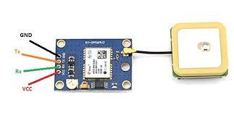

**NEO-6M GPS Receiver Module**

Global Positioning System (GPS) makes use of signals sent by satellites in space and ground stations on Earth to accurately determine its position on Earth. The NEO-6M GPS receiver module uses USART communication to communicate with the micro-controller or PC terminal.

**GSM/GPRS Module 800a**

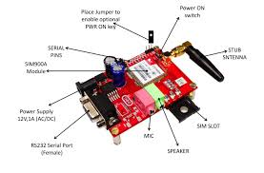

The Arduino GSM Shield V1 connects your Arduino to the internet using the GPRS wireless network. Just plug this module onto your Arduino board, plug in a SIM card from an operator offering GPRS coverage, and follow a few simple instructions to start controlling your world through the internet. You can also make/receive voice calls (you will need an external speaker and microphone circuit) and send/receive SMS messages.

**Button**

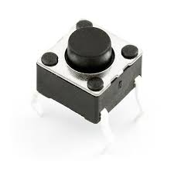

Buttons are commonly used in Arduino projects as inputs to trigger various actions, such as turning on and off lights, motors, or other devices. The Arduino Uno has several digital input pins that can be used to read the state of buttons and switches.

**LCD Display**

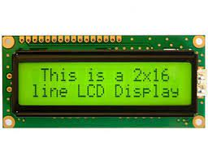

The LCD display is a commonly used output device in Arduino projects, and it can be easily interfaced with an Arduino Uno board. The LCD display is a great way to display text or other data in real-time and can be used in a variety of applications such as weather stations, electronic signage, and home automation systems.

**Fingerprint Sensor**

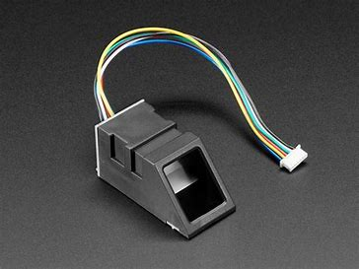

A Fingerprint sensor definition is a security system that is used to identify as well as authenticate an individual’s fingerprints to allow or reject access to a physical facility or a computer system. This sensor uses hardware & software combination techniques to recognize an individual’s fingerprint scans.

**LED (light-emitting diode)**

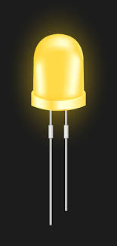

A light-emitting diode (LED) is a semiconductor light source that emits light when current flows through it. Electrons in the semiconductor recombine with electron holes, releasing energy in the form of photons. The color of the light (corresponding to the energy of the photons) is determined by the energy required for electrons to cross the band gap of the semiconductor. White light is obtained by using multiple semiconductors or a layer of light-emitting phosphor on the semiconductor device.

**4.4 Software Specification**

**Arduino IDE**

The Arduino integrated development environment (IDE) is a cross-platform application (for Windows, Mac OS and Linux) that is written in the programming language java. It is used and uploads programs to Arduino compatible boards.

The Arduino IDE supports the language C and C++ using special rules of codes structuring. The Arduino IDE supplies a software library from the wiring project which provides many common input and output input basic functions, for starting the sketch and the main program loop that are compiled and linked with a program

Arduino IDE is an open source that is mainly used for writing and compiling the code into the Arduino module. It is official software making code compilation too easy that even a common person with no prior technical knowledge can get their feet with the learning process.

A different range of Arduino modules available including Arduino Uno, Arduino mega, Arduino Nano, and many more. Each of them consist a microcontroller on the board that is actually programmed and accepts the information in the form of code. The IDE environment mainly contains two basic parts: Editor and compiler where former is used for writing the required code and later is used for compiling and uploading the code into the given Arduino module.

Arduino Integrated Development Environment (IDE) is an open source ide that allows user to write code and upload it to any Arduino board. Arduino is written in java and compatible with window, macOS and Linux OS.

**Tools**

* Auto format
* Archive Sketch
* Fix Encoding & Reload Fixes
* Serial Monitor
* Board
* Port

**CHAPTER 5**

**SYSTEM DESIGN**

**Block Diagram**

A block diagram is a drawing illustration of a system whose major parts or components are represented by blocks. These blocks are joined by lines to display the relationship between subsequent blocks. We use block diagrams to visualize the functional view of a system. It uses blocks connected with lines to represent components of a system.

**Flow Chart**

A flowchart is a picture of the separate steps of a process in sequential order. It is a generic tool that can be adapted for a wide variety of purposes and can be used to describe various processes, such as a manufacturing process, an administrative or service process, or a project plan.

The flow chart can assist in all manner of project processes, such as the planning of a new product, documenting that process, and modeling the business process for the project. It can also help you manage workflow, data, the auditing process and anything else that is process-based.

**Flow Chart 1 Diagram**

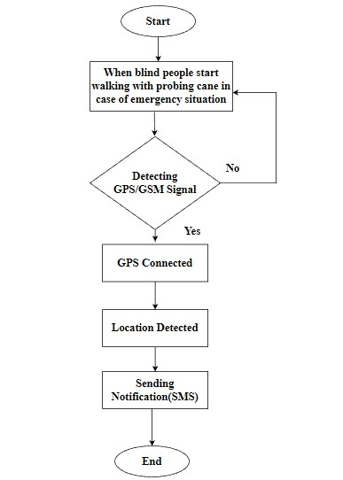

**Circuit Diagram**

The Circuit Diagram Document format is designed for storing electronic circuit designs. It stores the following information about a circuit: Layout: where components and wires are placed, to allow rendering a circuit as an image. Connections: how components are connected together to allow simulating a circuit.

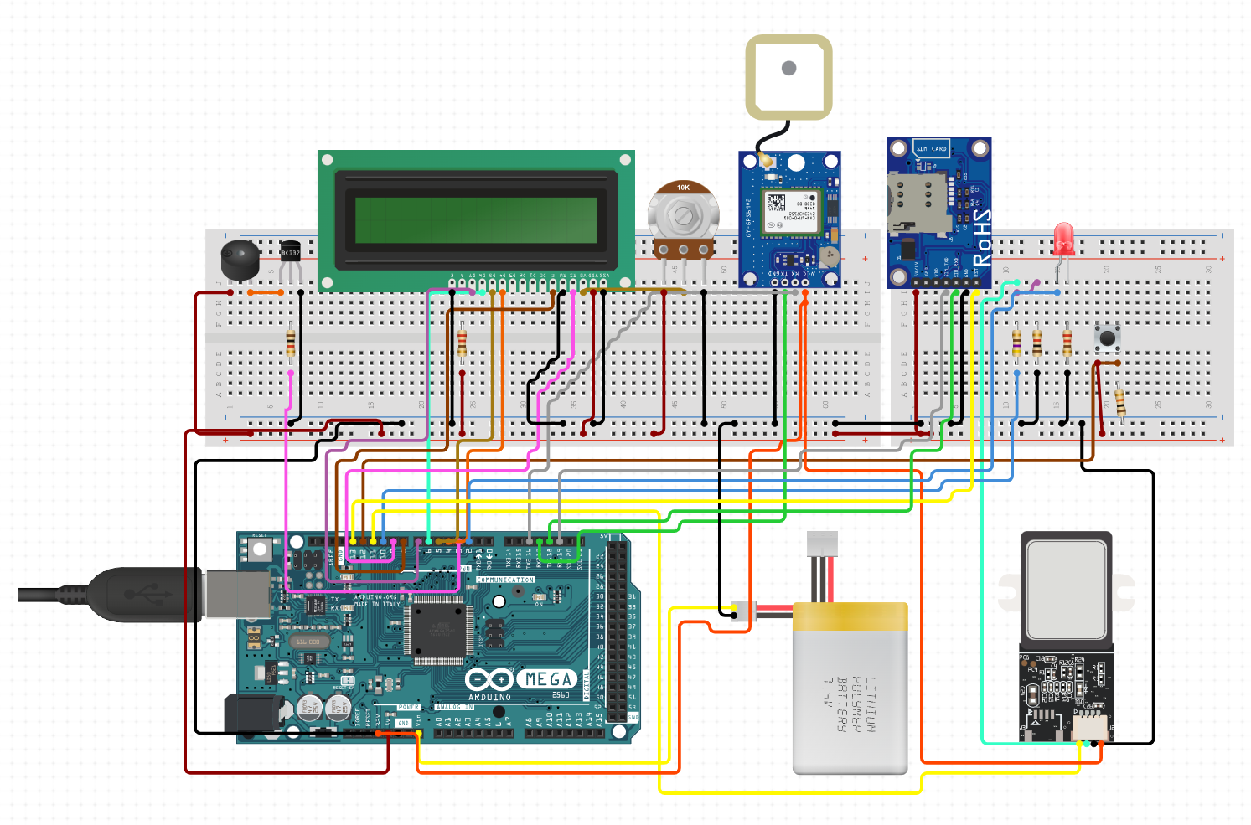

**CHAPTER 6**

**RESULT OF THE PROPOSED SYSTEM**

The project was made with the working hardware model, detecting the obstacles if come across any obstacles. The blind stick proposed model can aid the virtually impaired user by helping him/her navigate through different terrains and obstacles.

With the advantages, that it is low cost, fast response, low power consumption, lightweight, and ability to receive feedback through buzzer audio. Detecting the obstacle with the help of Ultrasonic sensors and it can provide notifications with GPS and GSM tracking in case of emergency situations.

In the end of our project, we can conclude that our project can reduce the number of risk and injuries for the visually impaired person when walking at public. Nowadays, even at young age experience the visually impairment. This thing cannot be taken so lightly as they know how much risk could it be. If the number of risk and injuries increasing rapidly, the kid or the person will lose their spirit to walk independently.

The Modern Blind Stick acts as a basic platform for the coming generation of more aiding devices to help the visually impaired to navigate safely both indoor and outdoor. It is effective and affordable. It leads to good results in detecting the obstacles on the path of the user in a range of two meters.

Though the system is hard-wired with sensors and other components, it's light in weight. Further aspects of this system can be improved via wireless connectivity between the system components, thus, increasing the range of the ultrasonic sensor and implementing a technology for determining the speed of approaching obstacles.

**CHAPTER 7**

**FUTURE ENCHANCEMENT**

In the future, if further improvement and investment are carried out with the stick then it will be an even more effective device for the future world.

In the future this project can be developed by adding GPS and GSM modules embedded with Gloves as well as coolers.

The model was used to track the location of the blind people. The emergency button was placed in their clothes or hats to make the device more portable and easy to use by blind people.

Furthermore, to assist in tracking the location, utilizes GPS to determine the location and send it via SMS to locate the location of the user.

In order to run this integrated set of hardware we can use solar panels as an alternative to the battery.

The use of solar panel occurs to be more advantageous as it uses sunlight, the easily available renewable resource of energy, to get recharged.

**CHAPTER 8**

**CONCLUSION**

At the end of our project, we can conclude that our project can reduce the number of risks and injuries for the visually impaired person when walking in public.

Nowadays, even at a young age experience visual impairment. This thing cannot be taken so lightly as they know how much risk could it be.

If the number of risks and injuries increases rapidly, the kid or the person will lose their spirit to walk independently

The Smart Stick acts as a basic platform for the coming generation of more aiding devices to help the visually impaired navigate safely both indoors and outdoors. It is effective and affordable.

**CHAPTER 9**

**BIBLIOGRAPHY**

**Book Reference**

1. Larisa Dunai, Guillermo peris Fajarnes, “Victor Santiago Praderas, Beatriz Defez Garcia, Ismael LenguaLengua-Real-Time Assistance Prototype-a new Navigation Aid for blind people”.978-1-4244-5226-2/10©2010IEEE.

2. Shamsi, M A.; A1-Qutayri, M.; Jeedella, J., “Blind assistance navigation system Biomedical Engineering (MECBME)”1st Middle east conference on 21-24 Feb 2011.

3. Borenstein J. and Ulrich I, “The Guide Cane-Applying Mobile Robot Technologies To Asist The Visually Imapaired”IEEE.

**Online Reference**

1.http://www.mecs-press.net/ijisa/ijisa-v6-n8/v6n8-6.html

2.https://pdfs.semanticscholar.org/35a4/74e95b193963f2bb4dbca220a76af40a13ee.pdf

3. https://store.arduino.cc/usa/arduino-uno-rev3

4. https://randomnerdtutorials.com/guide-for-relay-module-with-arduino/ https://en.wikipedia.org/wiki/Light-emitting_diode

**CHAPTER 10**

**APPENDIX**

**10.1 Sample Code**

#include <SoftwareSerial.h>

#include <TinyGPS.h>

#include <LiquidCrystal.h>

#include <Adafruit_Fingerprint.h>

#define RX_PIN 2

#define TX_PIN 3

#define LED_PIN 13

SoftwareSerial ss(RX_PIN, TX_PIN);

TinyGPS gps;

LiquidCrystal lcd(12, 11, 5, 4, 3, 2);

Adafruit_Fingerprint finger = Adafruit_Fingerprint(&ss);

void setup()

{

Serial.begin(9600);

ss.begin(9600);

lcd.begin(16, 2);

finger.begin(57600);

pinMode(LED_PIN, OUTPUT);

digitalWrite(LED_PIN, LOW);

lcd.print("Initializing...");

delay(1000);

lcd.clear();

}

void loop()

{

float lat, lng;

unsigned long start = millis();

while (millis() - start < 5000) // 5 seconds

{

while (ss.available() > 0)

{

if (gps.encode(ss.read()))

{

gps.f_get_position(&lat, &lng);

digitalWrite(LED_PIN, HIGH);

lcd.setCursor(0, 0);

lcd.print("Lat:");

lcd.print(lat, 6);

lcd.setCursor(0, 1);

lcd.print("Lng:");

lcd.print(lng, 6);

delay(2000);

digitalWrite(LED_PIN, LOW);

lcd.clear();

if (lat < 12.987 && lat > 12.986 && lng > 80.219 && lng < 80.220) // location of college

{

lcd.print("Panni button pressed");

delay(2000);

sendAlert();

}

else if (lat < 12.985 && lat > 12.984 && lng > 80.221 && lng < 80.222) // location of short distance

{

sendAlert();

}

break;

}

}

}

lcd.clear();

}

void sendAlert()

{

lcd.print("Sending alert...");

delay(2000);

// Check for fingerprint

int fingerprintID = finger.getImage();

if (fingerprintID == FINGERPRINT_OK)

{

lcd.clear();

lcd.print("Place your finger");

// Wait for valid finger

while (finger.image2Tz() != FINGERPRINT_OK)

{

lcd.setCursor(0, 1);

lcd.print("Invalid Fingerprint");

delay(2000);

lcd.clear();

lcd.print("Place your finger");

}

// Check if fingerprint is authorized

if (finger.verifyPassword())

{

lcd.clear();

lcd.print("Access Granted");

delay(2000);

lcd.clear();

lcd.print("You have safely");

lcd.setCursor(0, 1);

lcd.print("entered the bus");

delay(2000);

}

else

{

sendInvalidFingerprintMsg();

}

}

else

{

lcd.setCursor(0, 1);

lcd.print("Fingerprint Error");

delay(2000);

}

lcd.clear();

}

void sendInvalidFingerprintMsg()

{

lcd.clear();

lcd.print("Invalid Fingerprint");

delay(2000);

lcd.clear();

lcd.print("Access Denied");

delay(2000);

}